TEAMSTERS LOCAL UNION NO.19

Airline, Aerospace and Allied Employees – Arkansas, Louisiana, Oklahoma and Texas
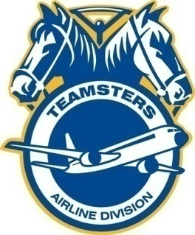
Houston
5939 Bender Rd
Humble, TX 77396
Phone: (713) 672-8155
Fax: (713) 672-9622

Robert Clever Dominic Fierro
President/Business Manager Secretary-Treasurer

June 13, 2014

SERCO

We are pleased to announce that Shelly Mills has been appointed the Union Steward serving the International Brotherhood of Teamsters Members for SERCO, at Fort Polk. Shelly has been instrumental during contract negotiations and is a great foundation for ensuring we are able to continue improving the quality of life and representation for our Members.

Please give Shelly your support as she will guide and assist you with the Contract, ensuring compliance through communicating effectively with both, SERCO and the IBT, Local 19.

Bob Clever

President and Business Manager Local 19

International Brotherhood of Teamsters

